**EXPERIMENT:18**:

**Aim:** To Create a Simple Web Application using Java or Python and host it in any Public Cloud Service Provider (Azure/GCP/AWS) to demonstrate Platform as a Service (PaaS).

**Implementation:**

STEP:1:: open azure and create account Go to resource groups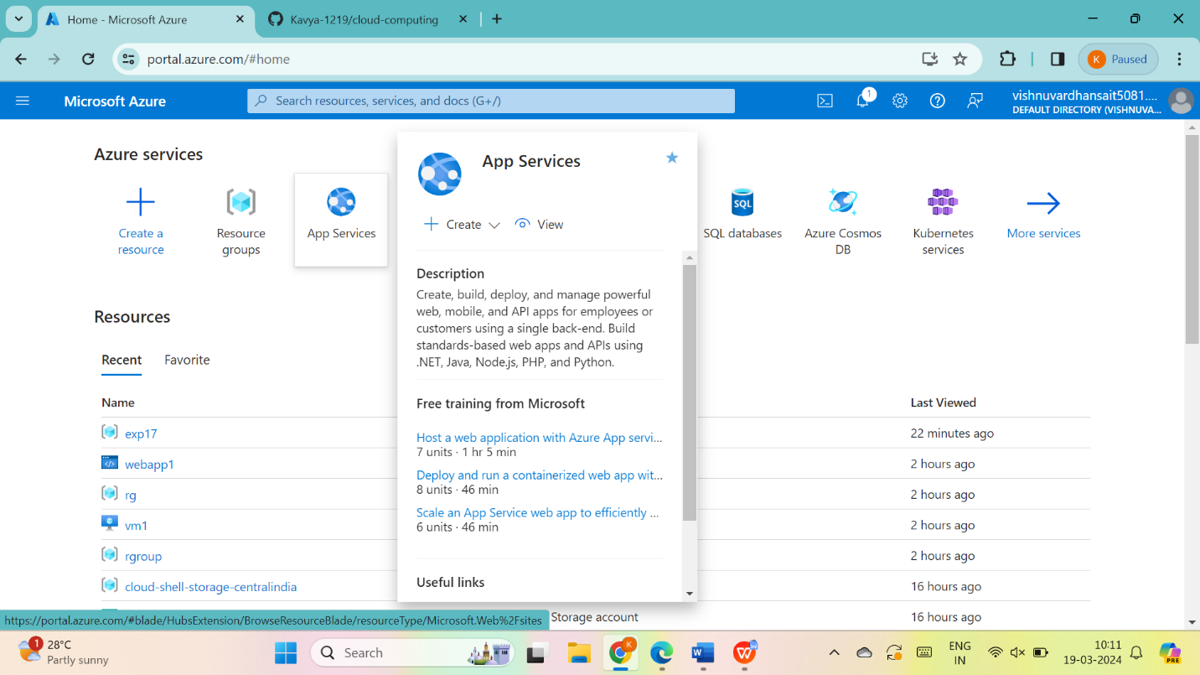THEN GO THE CREATE. 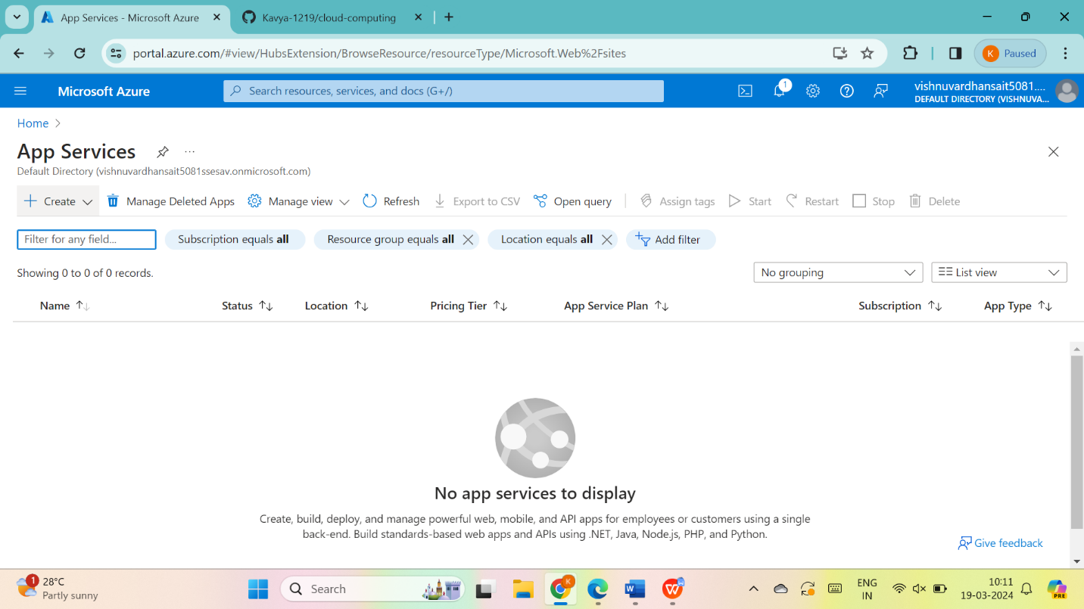

Go to static web app

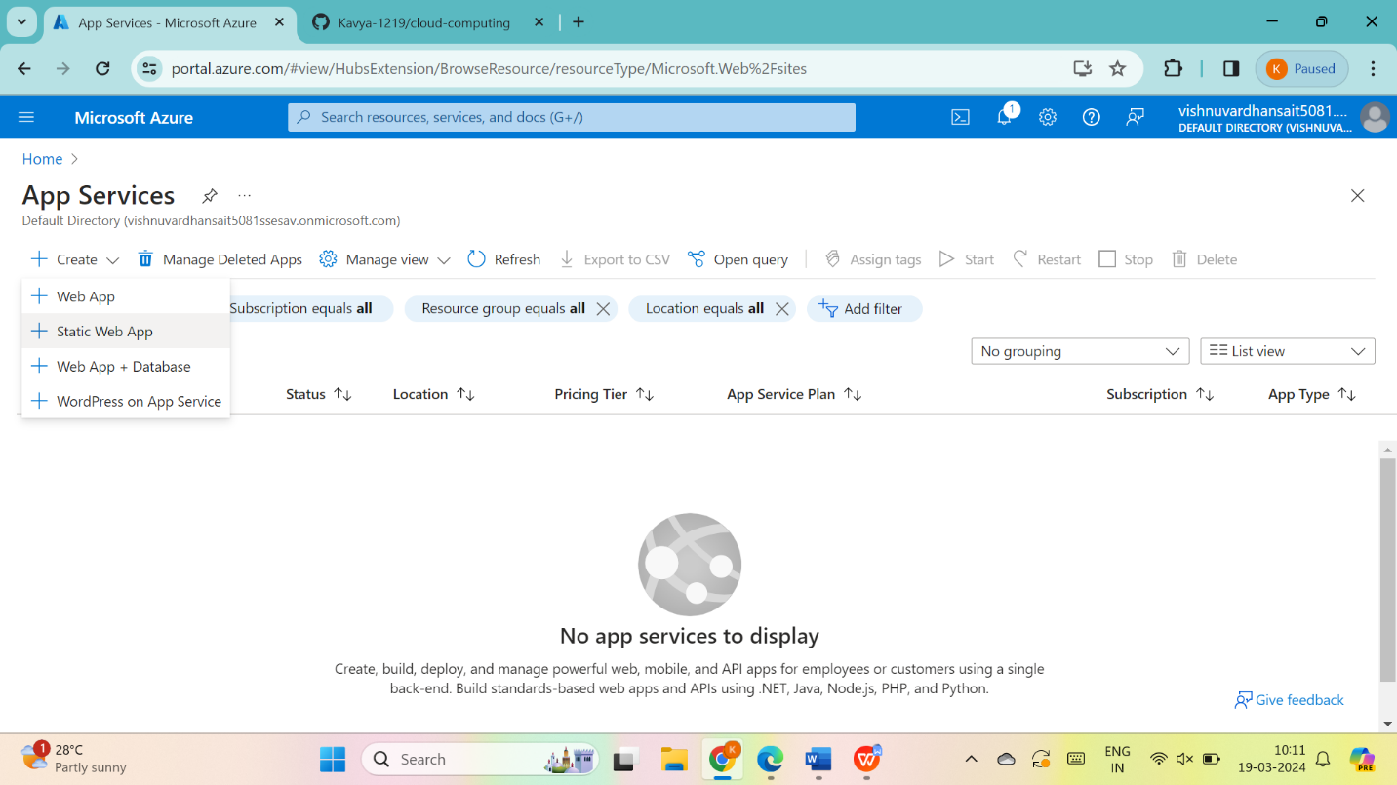

Give name to static web app and give next : advanced

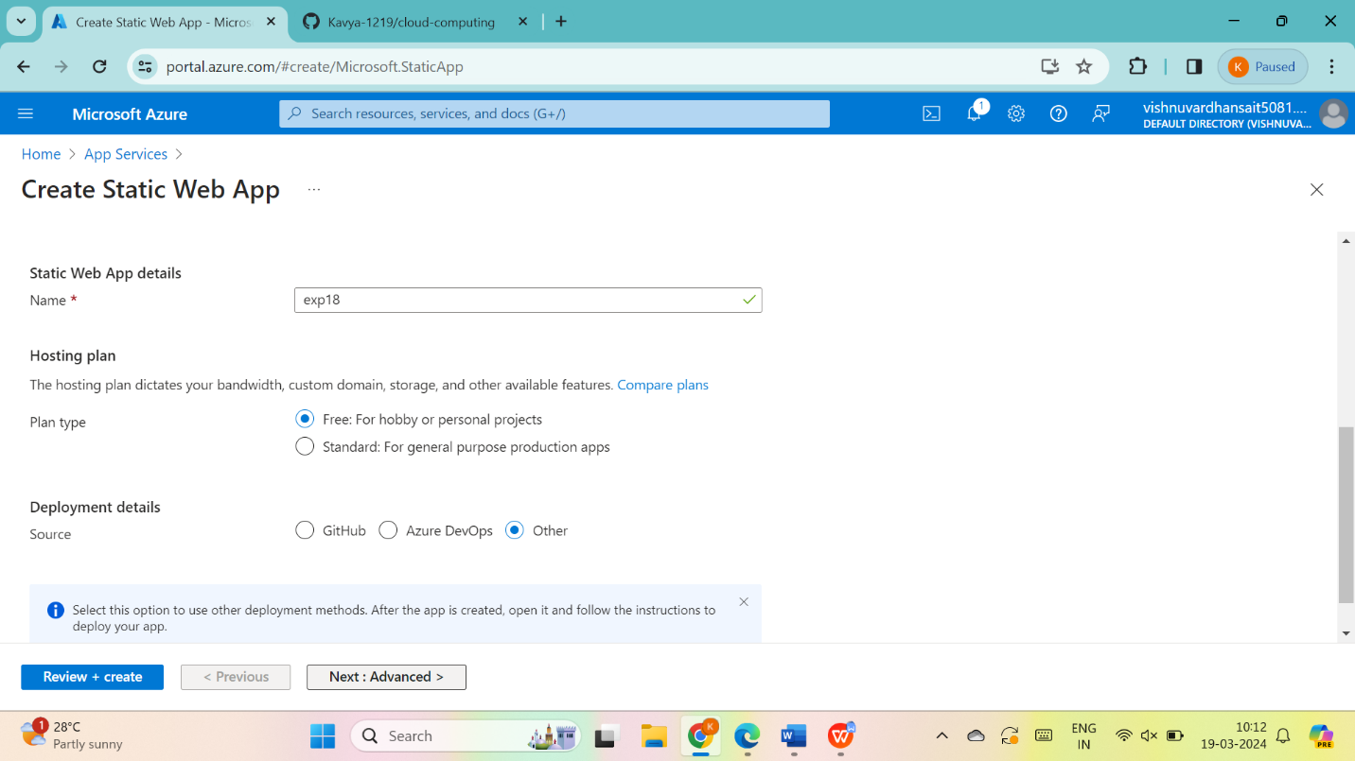

Fill the name and value and give next : review + create>

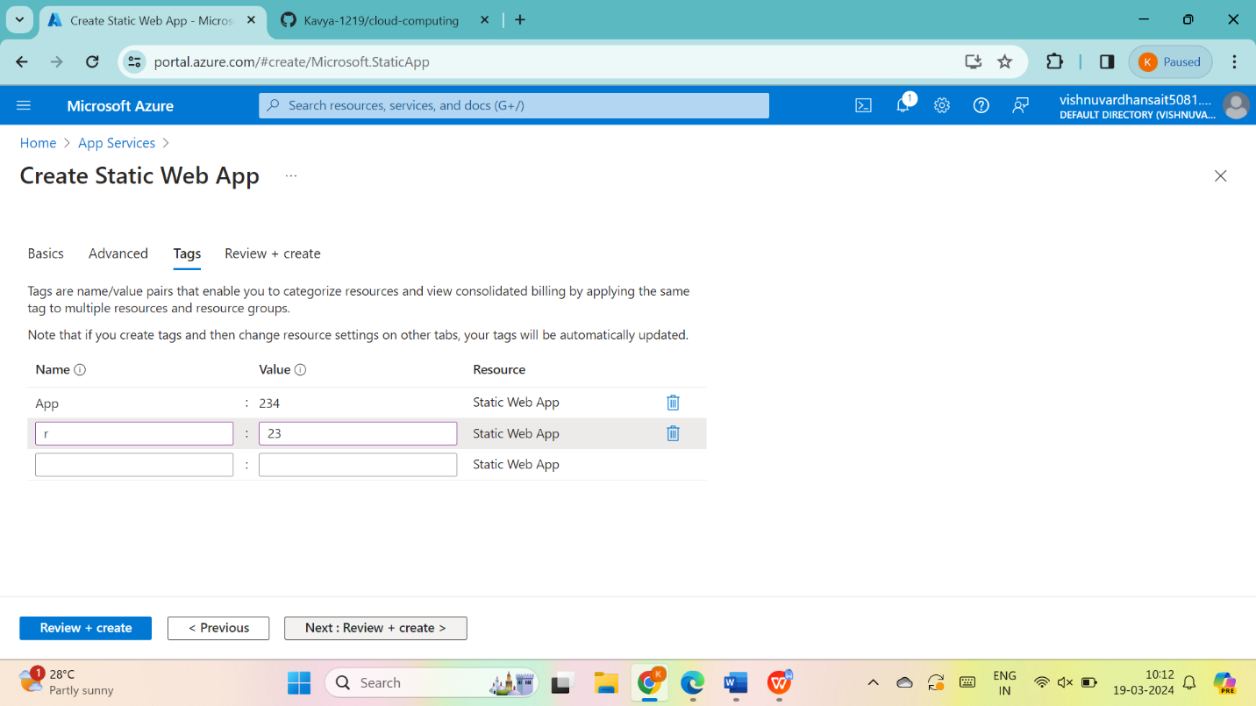

STEP:3:: go to create

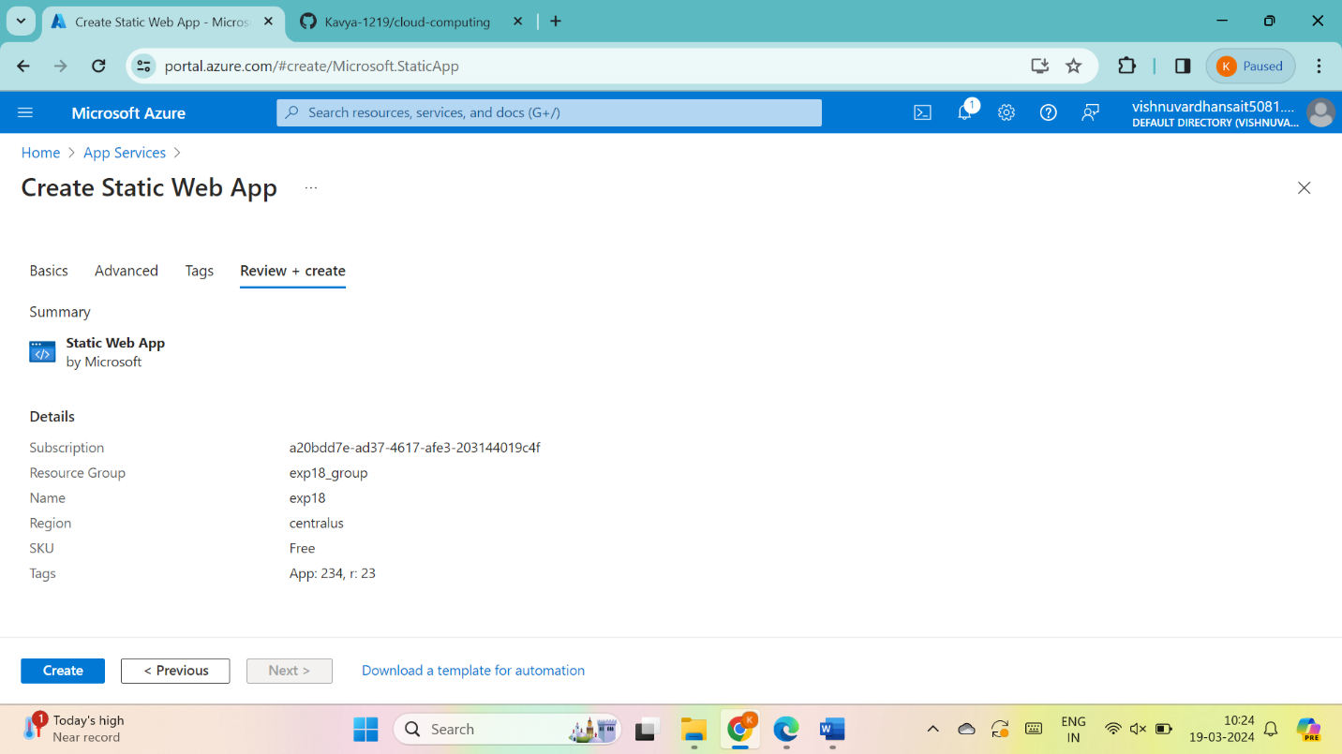

STEP:4:so the static web app was created then go to resource group

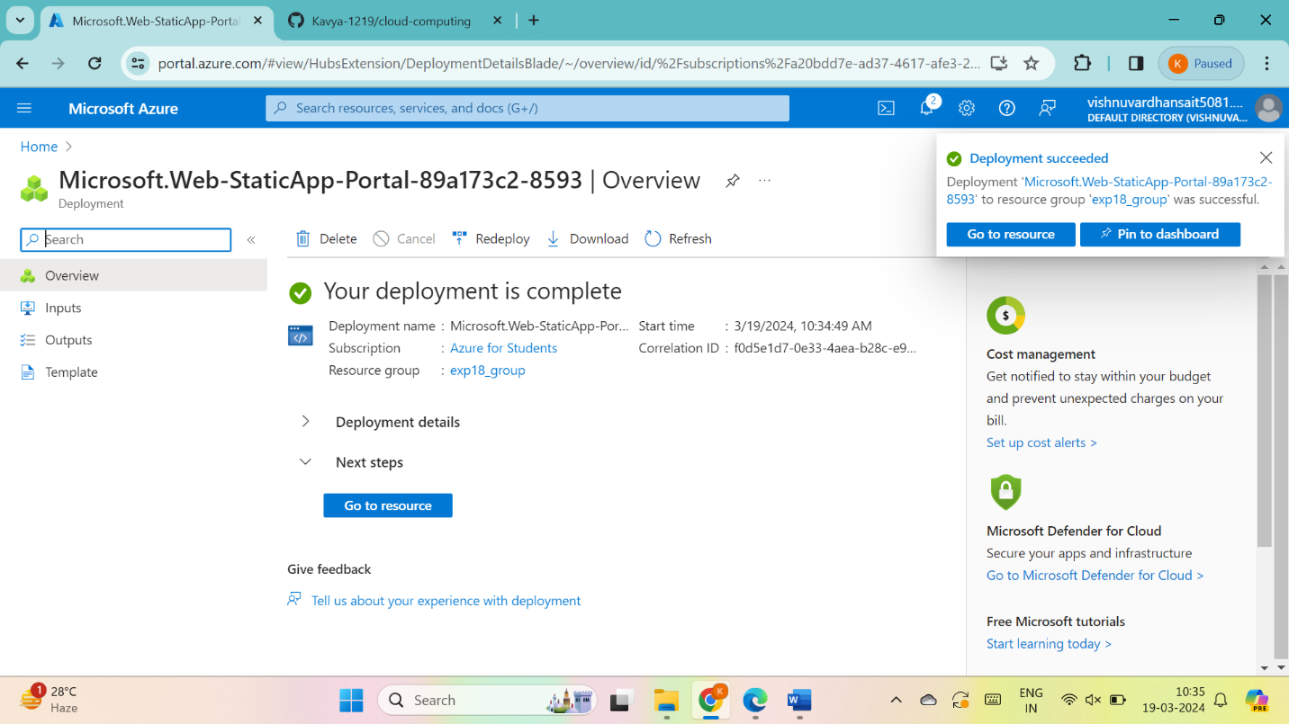

Copy down the URL and open in the browser

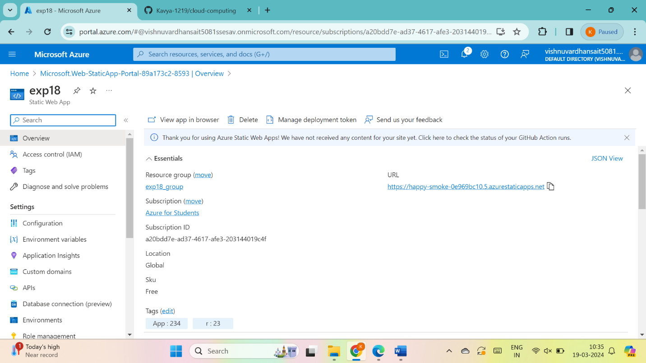

RESULT: THUS,THE PROGRAM FOR SIMPLE WEB APPLICATION IN AZURE HAS BEEN DONE SUCCESSFULLY



